**R with RDBMs Database (PostGreSQL)**

1: On Google Cloud Platform – SQL

Created a PostgreSQL instance

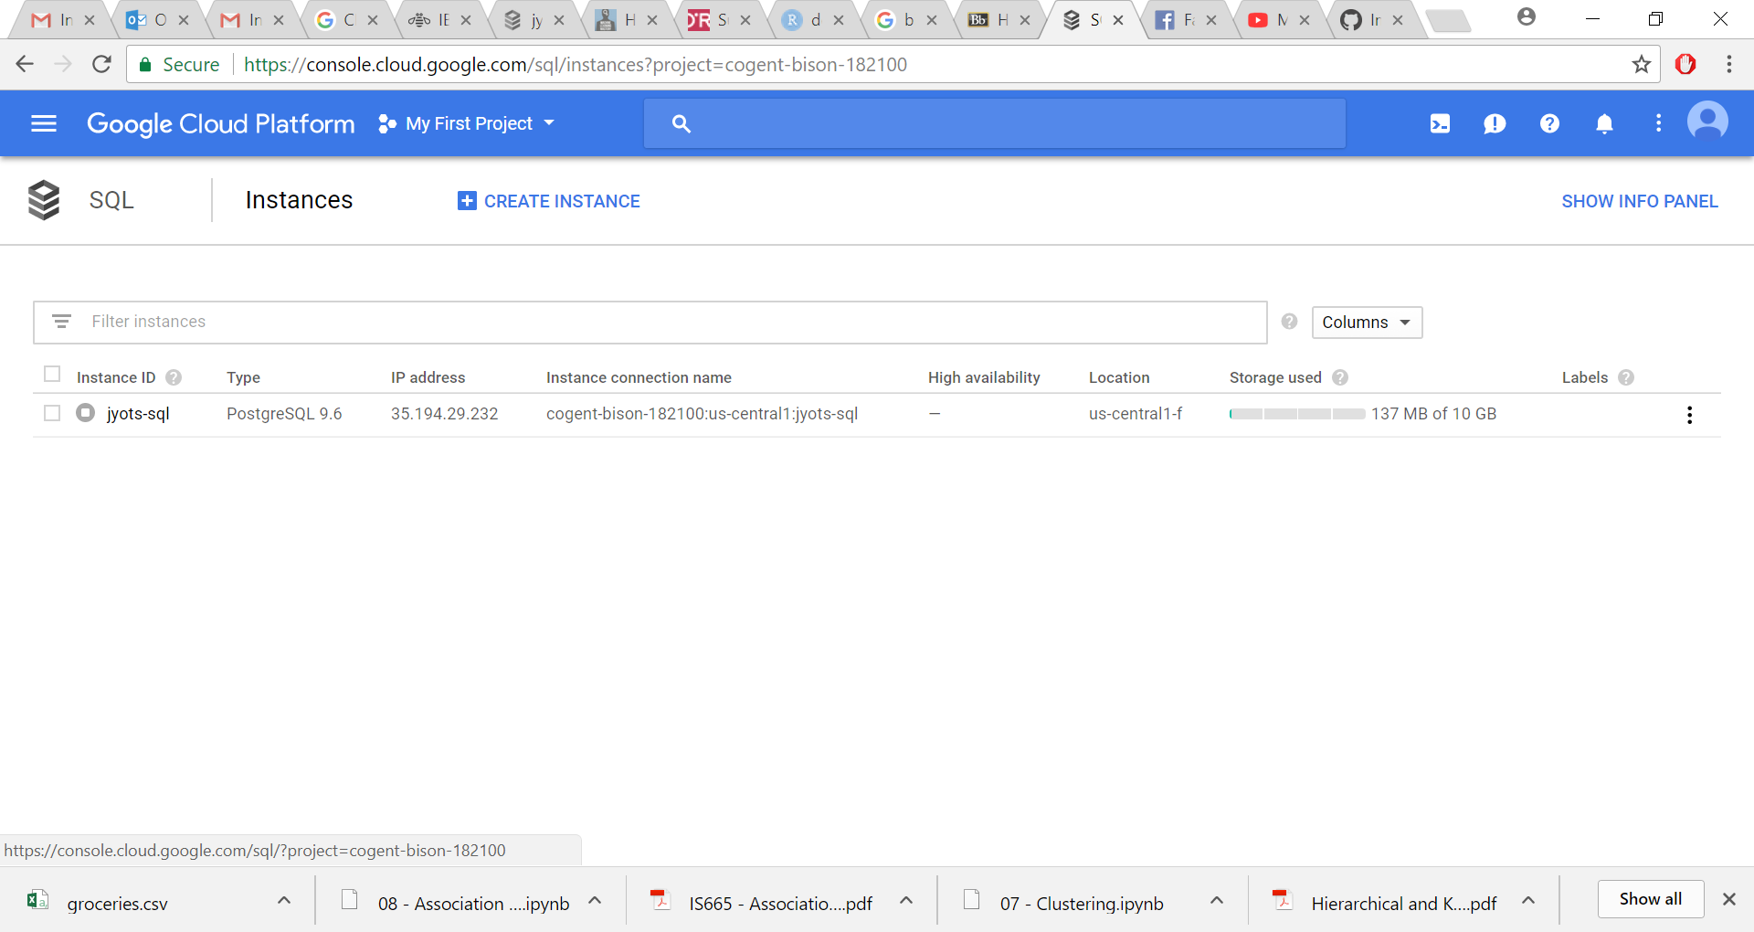

Connected to the database using RazorSQL

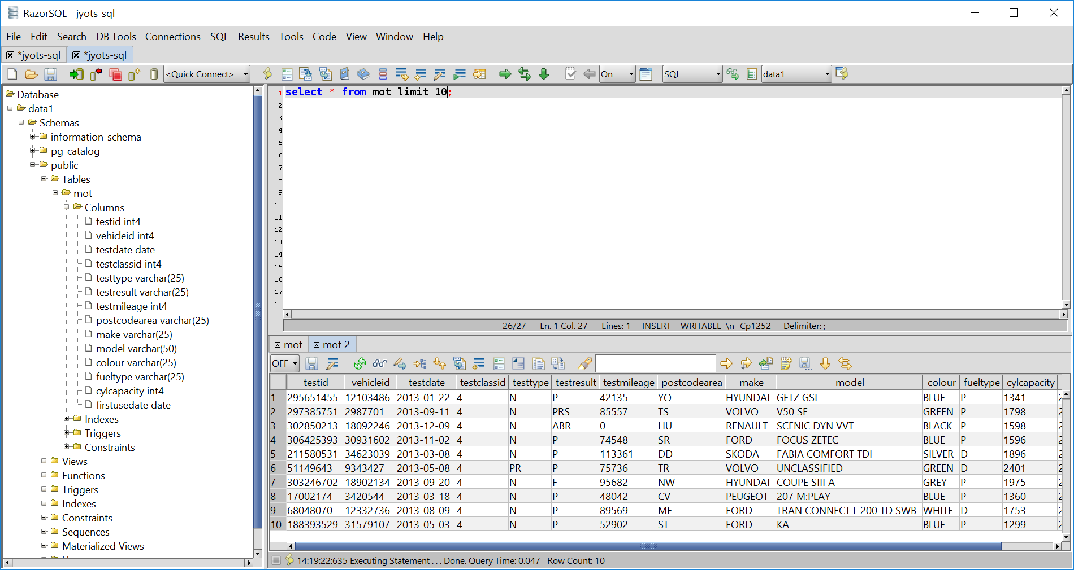

R studio integration components for PostgreSQL- Install

> devtools::install_github("RcppCore/Rcpp")

> devtools::install_github("rstats-db/DBI")

> devtools::install_github("rstats-db/RPostgres")

> library(DBI)

> library(RPostgres

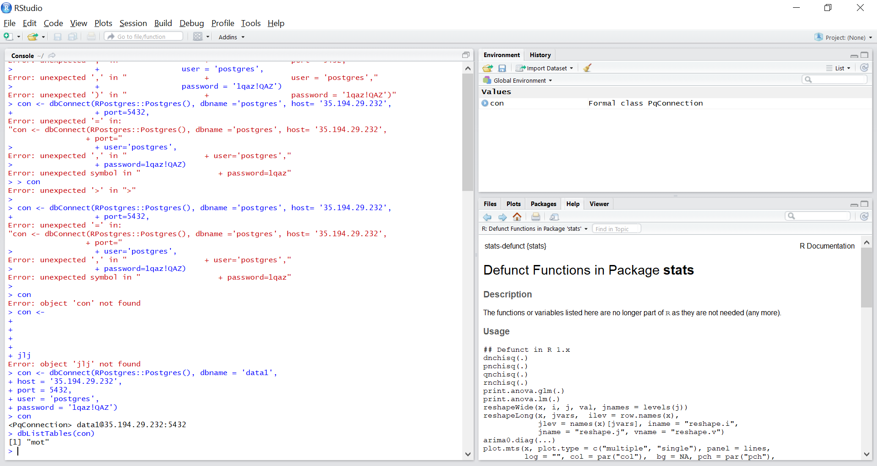

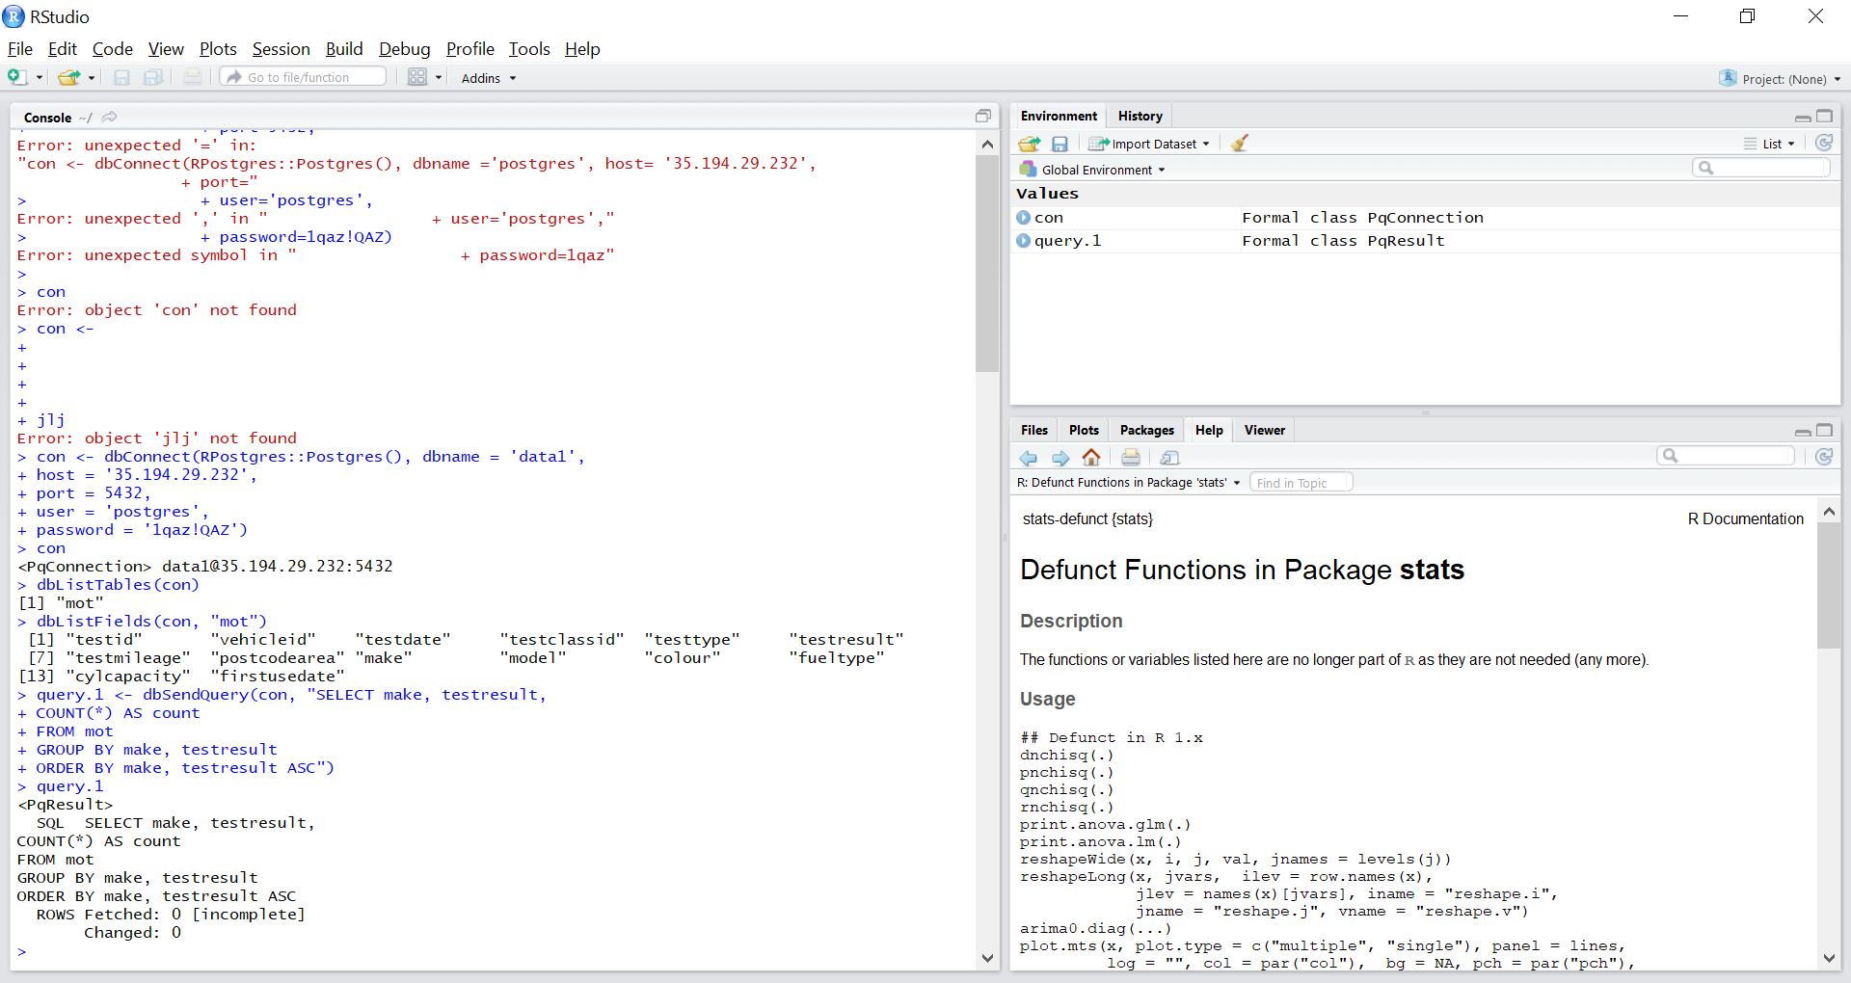

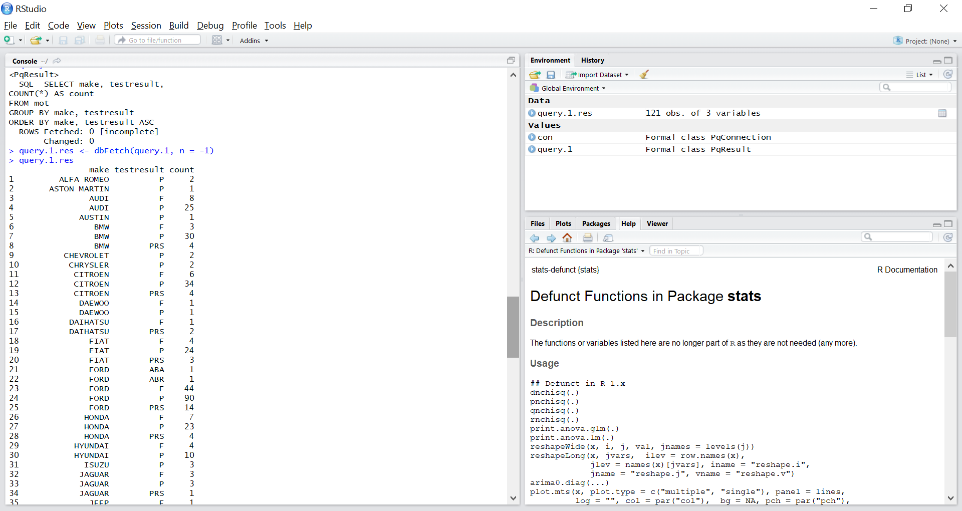

8.Second query

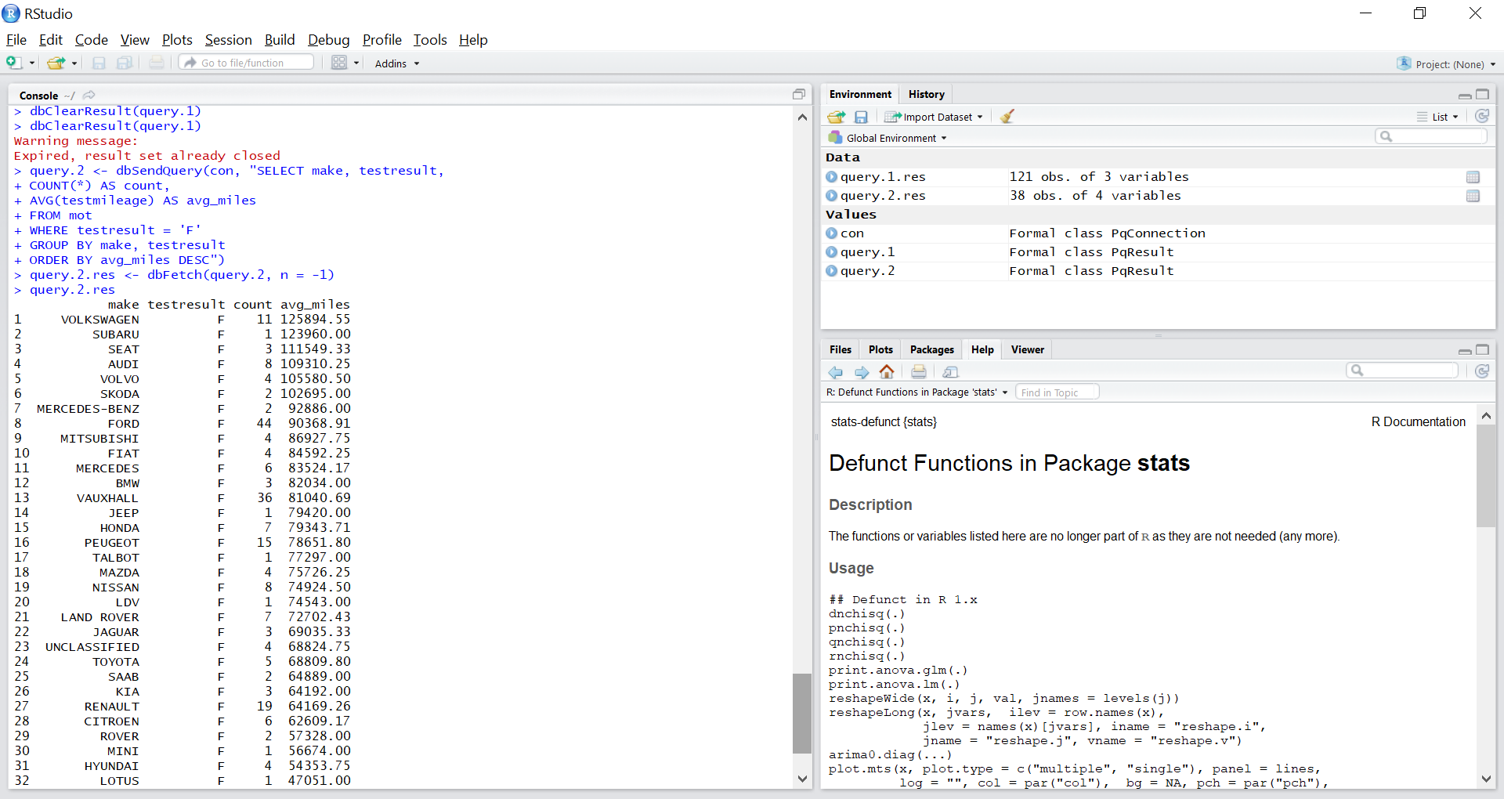

**9: Install RpostgreSQL**

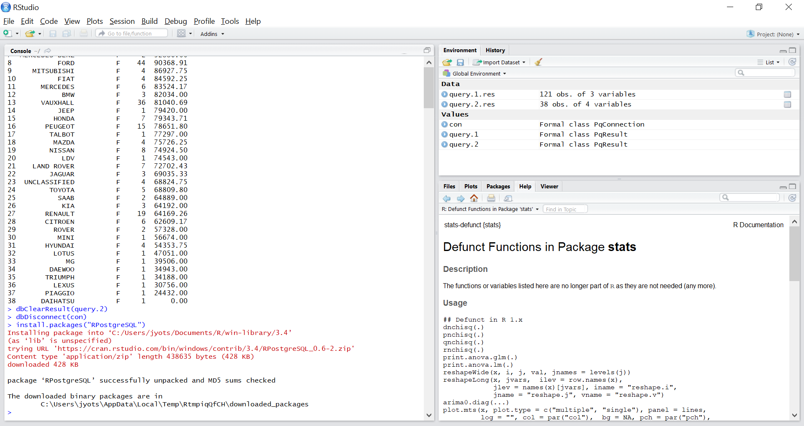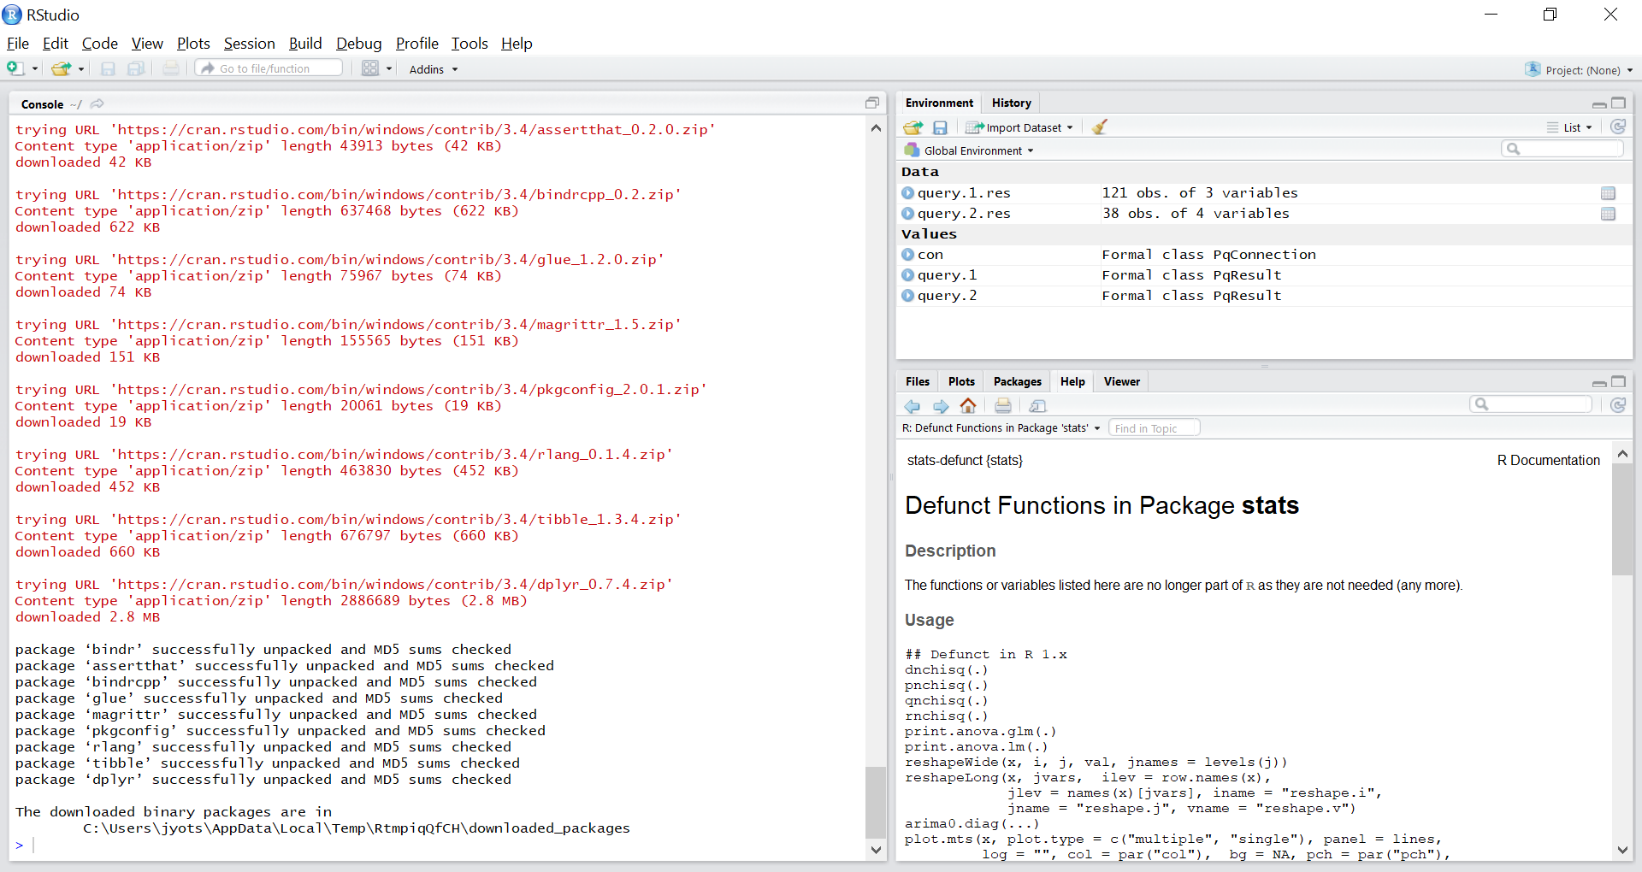

Connection -dpl

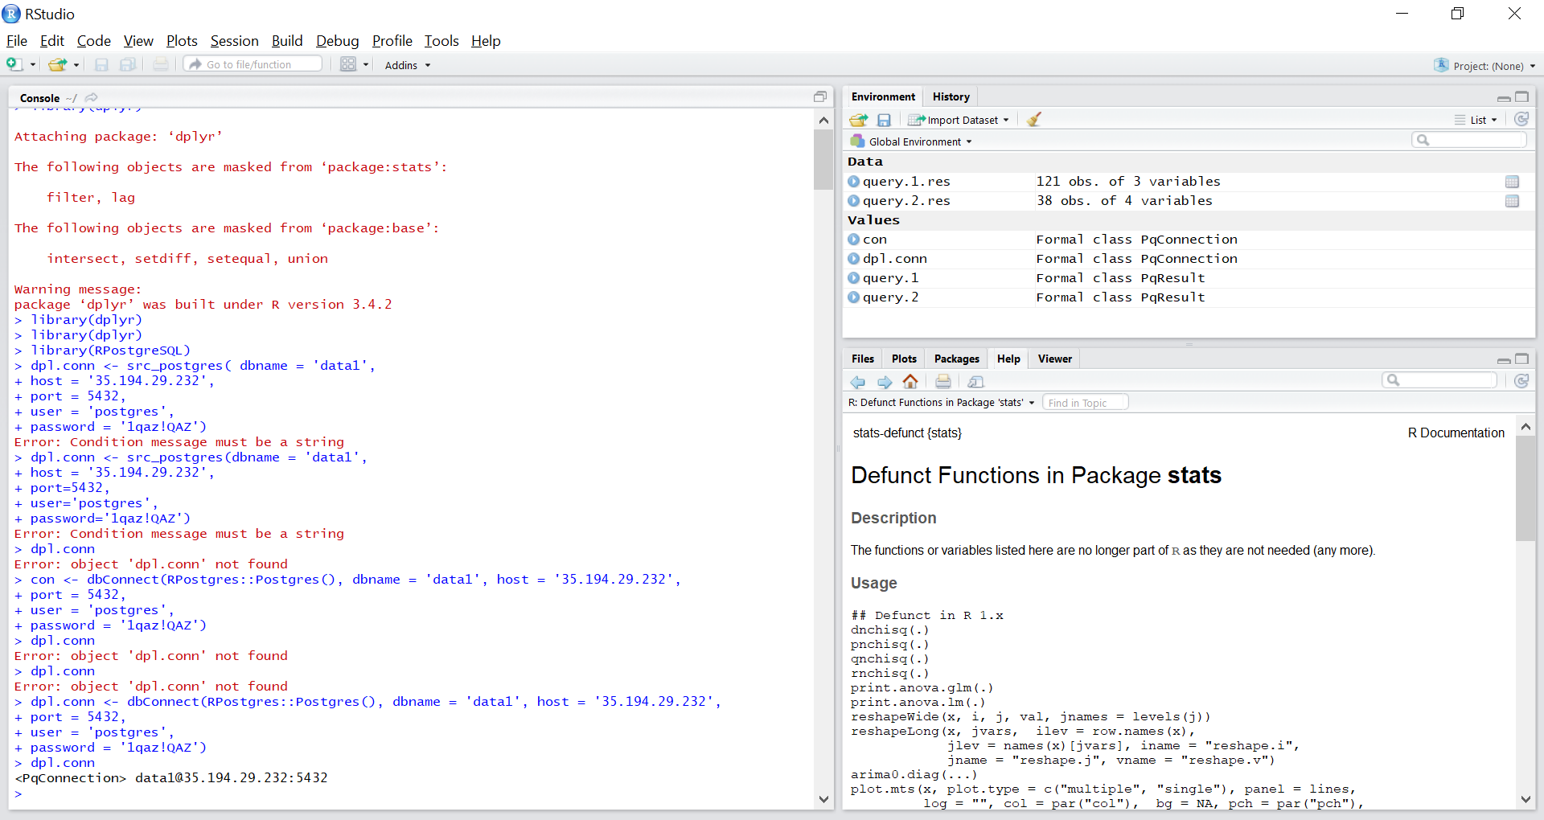

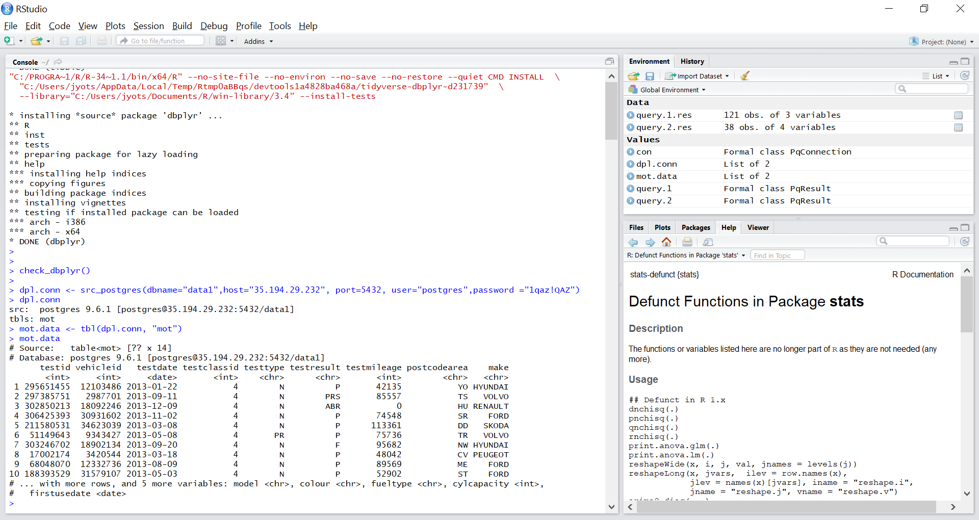

**Error while using glimpse :** Error in if (width[i] <= max_width[i]) next :

missing value where TRUE/FALSE needed

